Noeuds Géométriques
- Manuel (fr)
- Manual (en)
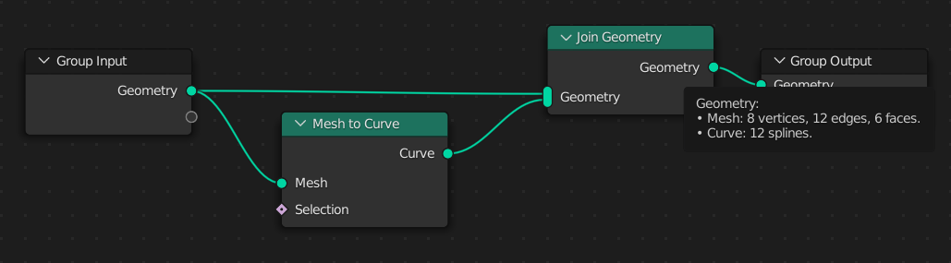
- GeometryNodesByTutorials
- Beginner guide
- Complete beginner guide
- Logic tutorial
- Shortcuts
- Samples
- Examples
- geometry-script
- NodeToPython
- Exemples d'objets paramétriques (YouTube)
- Easy Parametric Architecture in Blender with Geometry Nodes
- Easily create a building with Geometry Nodes in Blender like BIG Architecture's concepts
- Parametric Interior Design in Blender with Geometry Nodes

