Sverchok
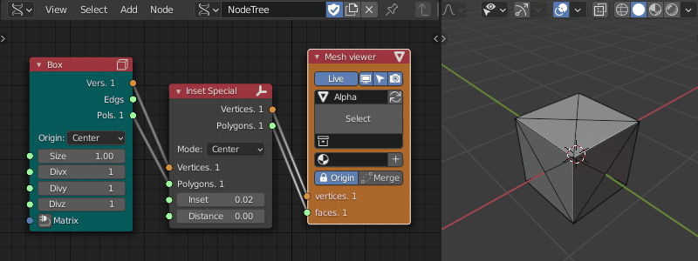
Image: Sverchok parametric modeling
- Sverchok
- Documentation

